CV5570 – Computer Vision for Construction Engineering
Object Detection

Assignment 02
By
Vasantharan K
ID26S012

Date: 02.10.2026

Assignment 2
CV5570 – Computer Vision for Construction Engineering
Objective
The objective of this assignment is to develop and evaluate an object detection pipeline for construction equipment using three different detector families: a two-stage detector, a one-stage detector, and a transformer-based detector.
The Annotated Construction Images Dataset (ACID) is used for the experiments. ACID was developed specifically for construction-machine detection and contains images of construction equipment with manually annotated object locations. The original ACID study reported 10,000 images covering 10 construction-machine categories and evaluated several object detection algorithms including YOLOv3, Inception-SSD, R-FCN-ResNet101, and Faster R-CNN-ResNet101.
For this assignment, the experiments are restricted to three classes:
- Excavator
- Dozer
- Dump Truck
The following three detectors are implemented:
- Two-stage: Faster R-CNN with ResNet-50-FPN
- One-stage: YOLOv8s
- Transformer-based: DETR with ResNet-50
The models are compared using detection accuracy, per-class average precision, inference speed, parameter count, training time, convergence behaviour, and qualitative success and failure cases.
The main objective is not only to determine which detector achieves the highest accuracy, but also to understand the practical trade-off between accuracy, computational cost, inference speed, and failure behaviour for construction-site monitoring.
Images/Dataset Description, Acquisition and Preprocessing
ACID Dataset
The ACID dataset is a construction-machine image dataset developed for deep-learning-based object detection. The dataset provides bounding-box annotations for construction machinery and was designed to support applications such as construction productivity monitoring and safety monitoring. The official ACID website states that annotations follow consistency, correctness, and completion standards, including annotation of visible and occluded construction machines.
For this assignment, a three-class subset was extracted containing 3,929 images and 7,614 annotated object instances.
The annotation data were available in both CSV and JSON formats. The CSV file was used as the primary annotation source during preprocessing because the bounding-box coordinates were directly available in tabular form.
The CSV annotation contains the following information: ”Image filename, Image width, Image height, Object class, xmin, ymin, xmax and ymax.”
The JSON annotation follows a structured image-category-annotation organization.
Dataset Statistics
Class | Images Containing Class | Instances
Excavator | 2,239 | 2,790
Dozer | 1,025 | 1,123
Dump Truck | 2,206 | 3,701
Total | 3,929 unique images | 7,614

The dataset therefore has a moderate class imbalance. Dump Truck is the most frequent class with 3,701 instances, while Dozer has the fewest instances with 1,123.
The class imbalance is important when interpreting the detector results because a model can achieve good overall performance while performing substantially worse on the less frequent Dozer class.
Bounding Box Analysis
For every annotation, the following quantities were calculated:
- Bounding-box width
- Bounding-box height
- Bounding-box area
- Bounding-box aspect ratio
- Bounding-box area relative to image area
The bounding-box width ranged from 12 to 3,768 pixels, while the height ranged from 10 to 2,696 pixels.
The mean bounding-box width was approximately 391.45 pixels, and the mean height was approximately 271.64 pixels.
The mean bounding-box aspect ratio was 1.51, with values ranging from 0.164 to 20.90.
The mean bounding-box area ratio was approximately 0.168, indicating considerable variation in the relative size of construction equipment within images.
These variations make the dataset suitable for comparing detectors under different object scales and aspect ratios.
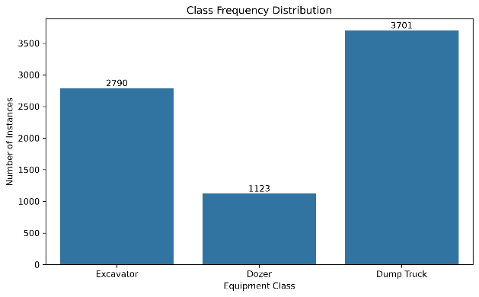  Fig 1. Class frequency distribution | 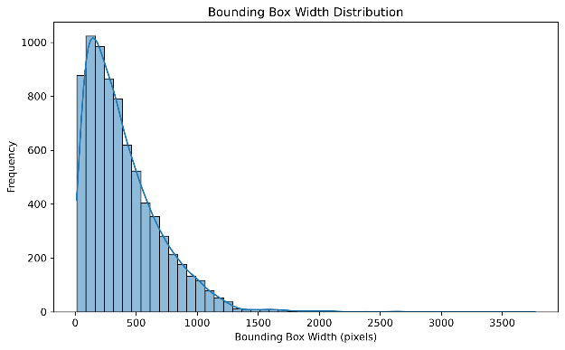  Fig 2. Bounding-box width distribution
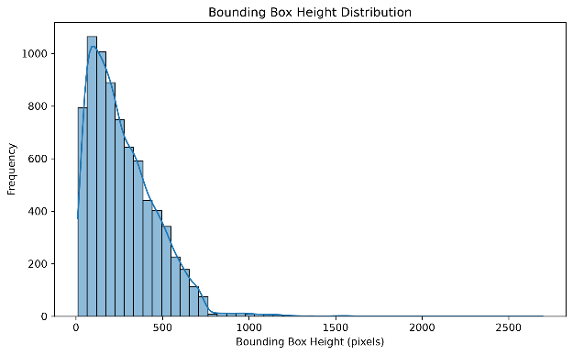  Fig 3. Bounding-box height distribution | 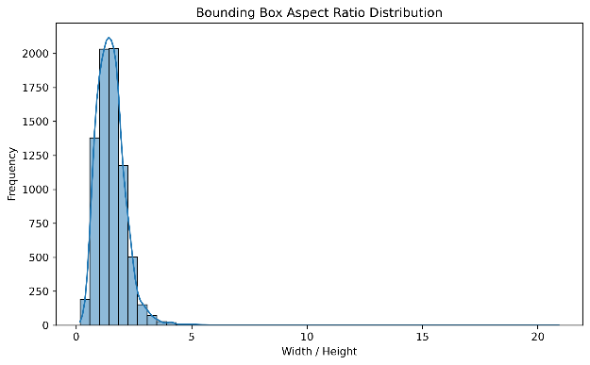  Fig 4. Bounding-box aspect ratio distribution
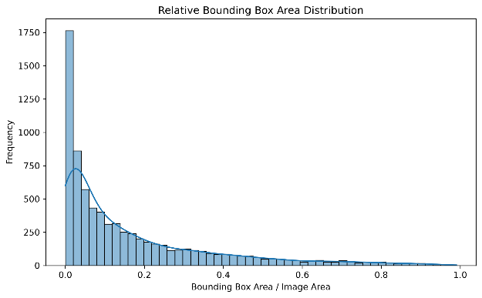
Fig 5. Relative bounding-box area distribution

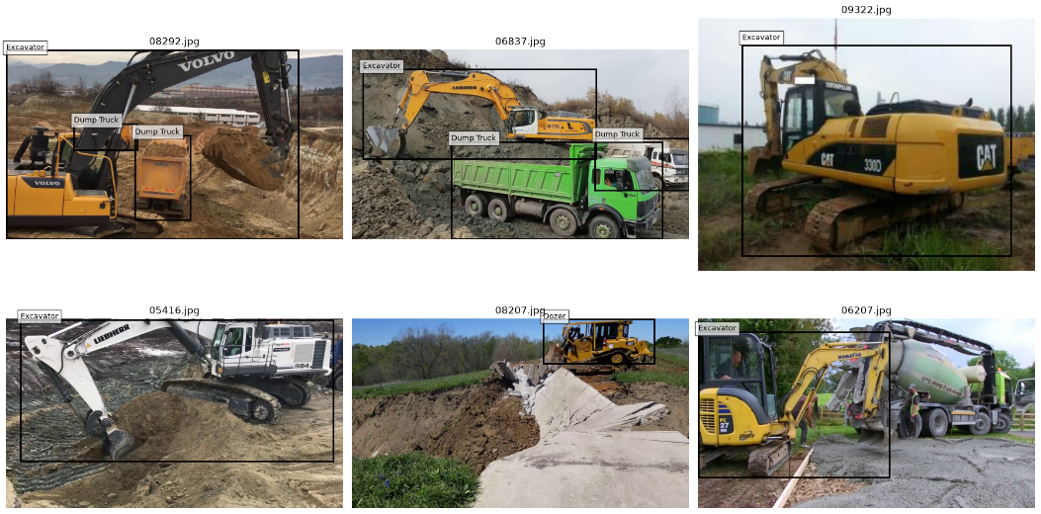
Fig 6. Six sample images with ground-truth bounding boxes
Train/Validation/Test Split
The dataset was divided at the image level into training, validation, and test sets using a 70:15:15 ratio.
A fixed random seed of 42 was used to make the split reproducible. Splitting was performed at the image level rather than at the bounding-box level so that annotations from the same image could not appear in different subsets.
The resulting split was:
Split | Images
Training | 2,750
Validation | 589
Test | 590
Total | 3,929
No overlap was found between the three image sets.
The number of annotated instances in each split was:
Split | Excavator | Dozer | Dump Truck
Train | 1,943 | 806 | 2,618
Validation | 418 | 161 | 528
Test | 429 | 156 | 555
The same image-level split was used across the detector families to maintain consistency in evaluation.

Two – Stage Object Detection

Model Configuration
The model used was:
Faster R-CNN + ResNet-50-FPN
The model was initialized with COCO-pretrained weights and fine-tuned for the three ACID classes.
Training Configuration
Parameter | Configuration
Model | Faster R-CNN ResNet-50-FPN
Pretrained weights | COCO
Classes | 3
Batch size | 2
Epochs | 10
Optimizer | SGD
Learning rate | 0.005
Momentum | 0.9
Weight decay | 0.0005
LR scheduler | StepLR
Step size | 3 epochs
LR decay | 0.1
Hardware | NVIDIA GeForce RTX 4070 Laptop GPU
Training time | 95.01 min

No additional image augmentation was introduced.
Training and Validation Loss
The Faster R-CNN training loss decrease d consistently during training.
Epoch | Training Loss | Validation Loss
1 | 0.2512 | 0.1938
2 | 0.1709 | 0.1730
3 | 0.1406 | 0.1634
4 | 0.0980 | 0.1536
5 | 0.0886 | 0.1516
6 | 0.0833 | 0.1552
7 | 0.0777 | 0.1564
8 | 0.0770 | 0.1566
9 | 0.0767 | 0.1570
10 | 0.0761 | 0.1571
The training loss continued to decrease throughout the ten epochs. The validation loss decreased rapidly during the first five epochs and then remained approximately stable. The small increase after epoch 5 indicates that further optimization primarily improved training loss without producing a corresponding improvement in validation loss.
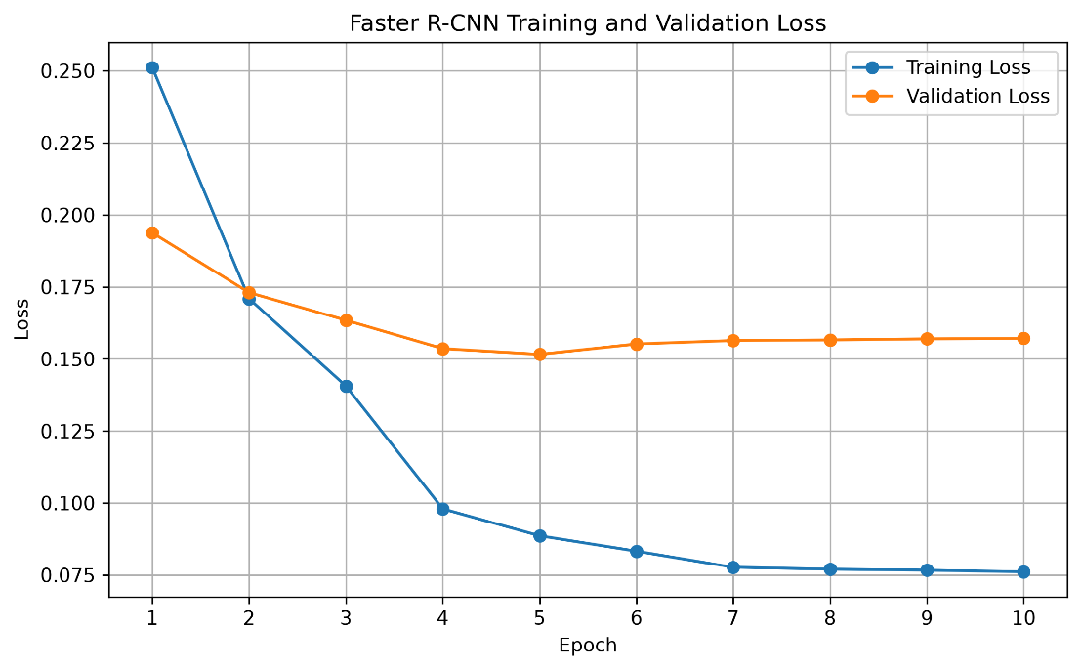
Fig 7. Faster R-CNN training and validation loss curve
Faster R-CNN Quantitative Results
The validation results were:
Metric | Result
mAP@0.5 | 0.9203
mAP@0.5:0.95 | 0.6931

The per-class AP values reported by the evaluation were:
Class | AP@0.5:0.95
Excavator | 0.7184
Dozer | 0.7382
Dump Truck | 0.6227
The Dump Truck class has the lowest AP among the three classes despite having the largest number of training instances. This suggests that class frequency alone does not determine detection performance and that factors such as appearance variation, object scale, occlusion, and localization difficulty can also affect performance.
Faster R-CNN Qualitative Results
Six qualitative examples were generated:
- Three successful detections
- Three failure cases
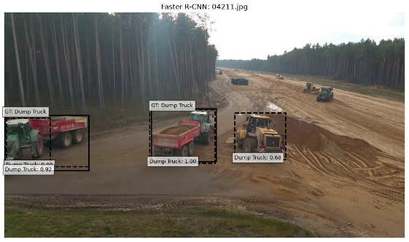 | 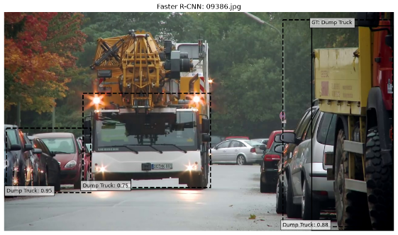 | 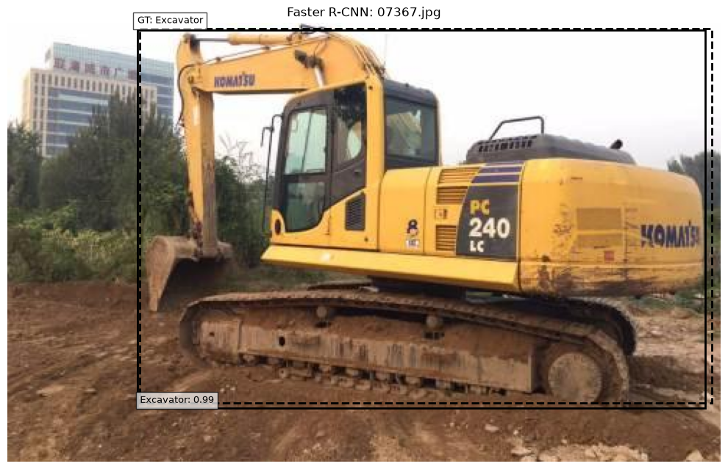

One – Stage Object Detection
YOLO
Transformer – Based Object Detection
Experimental Comparison
Limitations
Conclusion
References
Coding References
GitHub Link: https://github.com/vasantharan/CV5570_Assignment_2**
**Repo will be made public after submission deadline

- END -

